IRRIGATION DISTRICTS WARRANT LIST SPREADSHEET-Au |  |  |  |  | ust, 2019
Approved Venders | AMOUNT | ck# | FLATHEAD  /79.90% |  | MISSION  /13.8% | ck# | JOCKO  DIST/6.30% | TOTAL
Access Montana | 47.94 |  |  | 3712 | 23.97 |  | 23.97 | 47.94
Blackfoot | 83.70 |  |  |  | 41.85 |  |  | 83.70
Mission Valley Power Due | (83.84) |  |  |  |  |  |  | (83.84)
Republic Services | 25.68 |  |  |  | 12.84 |  | 12.84 | 25.68
Town of St Ignatius - WATER/WATER SEWER | 68.00 |  |  |  | 34.00 |  | 34.00 | 68.00
Whaley & Associates PC - WiX.com Web | 162.00 |  |  |  | 81.00 |  | 81.00 | 162.00
Whaley & Associates PC - WiX.com Web (Domain) | 13.95 |  |  |  | 6.98 |  |  | 13.95
Black Mountain | 987.00 |  |  |  | 987.00 |  |  | 987.00
Black Mountain | 987.00 |  |  |  |  |  | 987.00 | 987.00
United States Treasury - Aug payroll tax deposit | 183.60 |  |  |  | 183.60 |  |  | 183.60
 |  |  |  |  |  |  | 
Chantell Begay - Payroll - 9/12/2019 | 369.40 |  |  |  | 369.40 |  |  | 369.40
Chantell Begay - Payroll - 9/26/2019 | 369.40 |  |  |  | 369.40 |  |  | 369.40
Mission Irrigation District (Jocko's 1/2 of P/R & TAX) | 461.20 |  |  |  |  |  | 461.20 | 461.20
Local Government Services | 1,300.00 | 4367 | 1,300.00 |  |  |  |  | 1,300.00
Black Mountain | 1,859.00 | 4363 | 1,859.00 |  |  |  |  | 1,859.00
Montana Dept of Revenue - Payroll tax deposit | 41.00 | 4364 | 41.00 |  |  |  |  | 41.00
United States Treasury - Aug payroll tax deposit | 193.94 | 4365 | 193.94 |  |  |  |  | 193.94
Whaley & Associates PC - Monthly Accounting Fee | 900.00 | 4366 | 600.00 |  | 175.00 |  | 125.00 | 900.00
TOTAL | 7,968.97 |  | 2,693.94 |  | 2,278.06 |  | 1,766.86 | 7,968.97
 |  | Asof07/31/2019 |  |  |  |  |  | 
CASH BALANCE PER WARRANT REGISTER
FLATHEAD IRRIGATION - ADM  FLATHEAD IRRIGATION - O & M  MISSION IRRIGATION - ADM  MISSION IRRIGATION -O & M  JOCKO IRRIGATION - ADM  JOCKO IRRIGATION - O & M  FLATHEAD JOINT BOARD | 665,904  412,476  90,120  84,279  61,903  57,668  12,907
 |  | 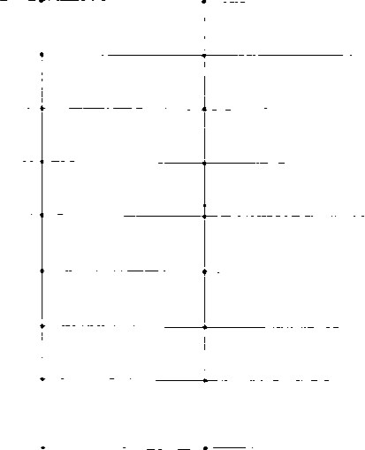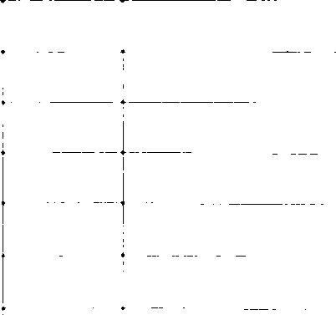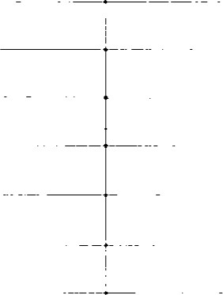
BALANCED WITH LAKE CO TREAS THROUGH JULY, 2019
9/6/2019

